**A**

**Project Report**

**On**

**Cafe Management System**

**Submitted by**

***Vraj Patel [210510106016]***

***Dhruvit Vegad [210510106034]***

***Niket Patel [210510104012]***

**as**

**Partial fulfilment of Semester V**

**of Bachelors of Computer Applications**

**for A.Y. 2023-2024**

**Under the Guidance of**

**Prof. Shikha Bansal.**

**Submitted To**

**Parul Institute of Computer Application,**

**Faculty of IT & Computer Science**

**Parul University**



**Acknowledgement**

*The success and final outcome of this project required a lot of guidance and assistance from many people and we are extremely privileged to have got this all along the completion of our project. All that we have done is only due to such supervision and assistance and we would not forget to thank them.*

*We respect and thank Dr. Priya Swaminarayan, Dean, FITCS for providing us an opportunity to do the project work in BCA and giving us all support and guidance, which made us complete the project duly. We are extremely thankful to Mam for providing her support and guidance, although she had busy schedule managing the academic affairs.*

*We would not forget to remember Dr. Hina Chokshi, HOD, BCA department for her encouragement and more over for her timely support and guidance till the completion of our project work.*

*We owe our deep gratitude to our project guide Prof. Shikha Bansal, who took keen interest on our project work and guided us all along, till the completion of our project work by providing all the necessary information for developing a good system.*

*We are thankful to and fortunate enough to get constant encouragement, support and guidance from our Parents, all Teaching staffs of BCA Department which helped us in successfully completing our project work. Also, we would like to extend our sincere esteems to all staff in laboratory for their timely support.*

***Vraj Patel: 210510106016***

***Dhruvit Vegad: 210510106034***

***Niket Patel: 210510104012***



**PARUL INSTITUTE OF COMPUTER APPLICATION**

**CERTIFICATE**

This is to certify that ***__Vraj Patel, Dhruvit Vegad, Niket Patel _***the student(s) of Parul Institute of Computer Application, has/have satisfactorily completed the project entitled “***_Cafe Management System_”*** as a part of course curriculum in BCA semester-V for the academic year 2023-2024 under guidance of ***_Prof. Shikha Bansal.***

Enrolment Number: 210510106016

Enrolment Number: 210510106034

Enrolment Number: 210510104012

|  |  |  |
| --- | --- | --- |
| **Quality of work** | **Grade** | **Sign of Internal guide** |
| **Poor / Average / Good /Excellent** | **B /B+ / A / A+** |  |

Date of submission:

HOD, Principal,

Dr. Hina Chokshi Dr. Priya Swaminarayan

**INDEX**

|  |  |
| --- | --- |
| **Content** | **Page No.** |
| 1. Research | 1 |
| 1. Feasibility Studies | 2 |
| * 1. Technical Feasibility | 2 |
| * 1. Economic Feasibility | 2 |
| * 1. Operational Feasibility | 2 |
| 1. System Requirement Specification | 4 |
| * 1. Introduction to SRS | 4 |
| * 1. Abstract | 4 |
| * 1. System Users | 5 |
| * 1. Modules | 5 |
| * 1. Modules Description | 5 |
| * 1. Hardware / Software Requirement | 6 |
| * 1. Flow Chart | 7 |
| * 1. TimeLine Chart | 8 |
| 1. Technology Description | 9 |
| * 1. Features and Limitations of New System | 9 |
| 1. Data Flow Diagram | 9 |
| * 1. Context Level DFD’s | 9 |
| * 1. Level 1 DFD’s | 10 |
| * 1. Level 2 DFD’s | 11 |
| * 1. Level 3 DFD’s | 12 |
| 1. Use Case Diagram | 15 |
| 1. Class Diagram | 16 |
| 1. Activity Diagram | 17 |
| * 1. Description of Activity Diagram | 17 |
| 1. E-R Diagram | 18 |
| * 1. E-R Diagram Description | 18 |
| 1. Data Dictionary | 19-21 |
| * 1. Description of Data Dictionary | 21 |
| 1. Form Design (Screenshots Phase 1, 2, 3, 4 and Validation’s Screenshots) | 22-29 |
| 1. What is Testing? | 30 |
| * 1. Importance and Types of Testing | 30 |
| 1. Future Enhancement | 31 |
| 1. References and Bibliography | 32 |

1. **Research**
   1. **What is research?**

Coffee shops are known to be one of the most visited places for a person

to be productive in terms of work and creating ideas. It is the staple of the

hospitality industry for a good reason. According to Fisher, Landry, & Naumer

(2007), Hattox (2014) and Waxman (2006), Individuals tend to spend the

majority of their budget on coffee consumption mainly because it serves as a

multi-beneficial investment for studying, working, and socializing. The

literature on the economic value of coffee shop businesses has been discussed

by various data sources. According to Ibis (2011), in 2010 the size of the

economy in this industry was roughly 26.5 billion dollars, with 4.1% yearly

development in normal. Therefore, the industry contributes considerably to the

world’s economy. According to Ibis (2011), the coffee shop businesses tend to

be created commonly, however competitions are intense. Therefore, it is

crucial to understand the market in order to be ahead of competition given the

economic uniqueness and value as it will provide continuous profits.

According to Han & Hyun, Jung & Yoon Kim, Vogt &

Knutson Ryu, Han, & Kim and Ryu, Lee & Kim,

consumer behaviour has concluded the role of satisfaction in the market. An

enormous assortment of literature provides that customer satisfaction is a

centre component of the service industry as it will in general give a positive

relationship of outcomes such as a higher significant level of sales and

customer loyalty. Despite is an important role, past researches have rarely

examined the idea behind customer satisfaction and its attributes of a coffee

shop business. To solve the gap in the literature, the purpose of this research is

to find out satisfaction-related customer personality and attributes that can

impact satisfaction as it is a core of coffee sales success.

1. **Feasibility Studies in our proposed System**

**What is Feasibility?**

A Feasibility study is performed by a company when they want to know whether a project is possible given certain circumstance. There are three types of feasibility study are:

* Technical Feasibility
* Economy Feasibility
* Operational Feasibility
  1. **Technical Feasibility**
* The technical feasibility in the proposed system deals with technology used in the system. It deals with the Hardware and Software used in the system whether they are of latest technology or not.
* Technical feasibility study is the complete of the project in term of input, output, program and its language etc.
* In this project we are using language which are commonly use to all of us that is English.
* The whole project is made in Microsoft visual studio.
* We are using this technology because it is easy to understand.
  1. **Economic Feasibility**

This assessment typically involves a cost/ benefits analysis of the project, helping organizations determine the viability, cost, and benefits associated with a project before financial resources are allocated.

* 1. **Operational Feasibility**

An operational feasibility study evaluates whether or not the shop is able to complete this project. This includes staffing requirements, organizational structure, and any applicable legal requirements.

* 1. **Importance of Feasibility Studies**

An operational feasibility study evaluates whether or not the organization is able to complete this project. This includes staffing requirements, organizational structure, and any applicable legal requirements.

1. **System Requirement Specification**
   1. **Introduction To SRS**
      1. **What is SRS?**

A software requirements specification (SRS) is a description of a software system to be developed. It lays out functional and non-functional requirements, and may include a set of use cases that describe user interactions that the software must provide.

* + 1. **Need of SRS**

In order to fully understand one’s project, it is very important that they come up with a SRS listing out their requirements, how are they going to meet it and how will they complete the project. It helps the team to save upon their time as they are able to comprehend how are going to go about the project. Doing this also enables the team to find out about the limitations and risks early on.

* 1. **Abstract**
* Cafe Management System is based on a concept to maintain orders and management of a particular coffee shop.
* The aim of the cafe management is to create communication between rural area people and cafe management.
* This project automates the process of manually maintaining the records related to transaction flows, user details, payment details. It is very needy for Cafe Shops. This project helps the owners of Cafe Shops to maintain day to day transactions in computer.
* This project deals with management of the coffee it deals the purchase and sale of coffee.
  1. **System Users**
* **Admin**
* **Customer**

**3.3.1. Description of User’s Role**

**Admin:**

Responsibility for maintaining Online product pricing & plans ensuring that price changes are implemented in an accurate & timely manner.

**Customer:**

Customer service refers to the process of providing assistance to online customers from making better purchase decisions to resolving issues all while creating a seamless customer experience across multiple touchpoints.

* 1. **Modules**
* **Admin Module**
* **User/Customer Module**
  1. **Modules Description**
* **Admin Module:**

Category manage: Here admin will be able to add, update and delete categories for the products.

Sub Category manage: Here admin will be able to add, update and delete subcategories for the products.

Products manage: Here admin will be able to add, update and delete products.

Manage users list: Here admin will be managing the users list, updating and deleting the users list.

* **User/Customer Module:**

Users can sign up and login into the site to buy items. To shop for any item users will have to first see choose the item.

Users can select the product. According to the selection user can add items to the cart. Then users can select the item out after adding all the desired item to their cart.

User can also see it order history and order status.

* 1. **Hardware Requirements**

|  |  |
| --- | --- |
| **Name of Components** | **Specification** |
| Processor | Intel core i3/i5 or above |
| RAM | 4GB/8 GB |
| Hard Disk | 512GB/1TB |

**3.6. Software Requirements**

|  |  |
| --- | --- |
| **Name of Components** | **Specification** |
| Operating System | Windows XP, Windows10 or above |
| Software development Kit | Google Chrome, Internet Explorer,  Mozilla Firefox (any appropriate or suitable browser) |
| Tools & languages | PHP, Xampp Control Panel |

* 1. **Flow Chart**

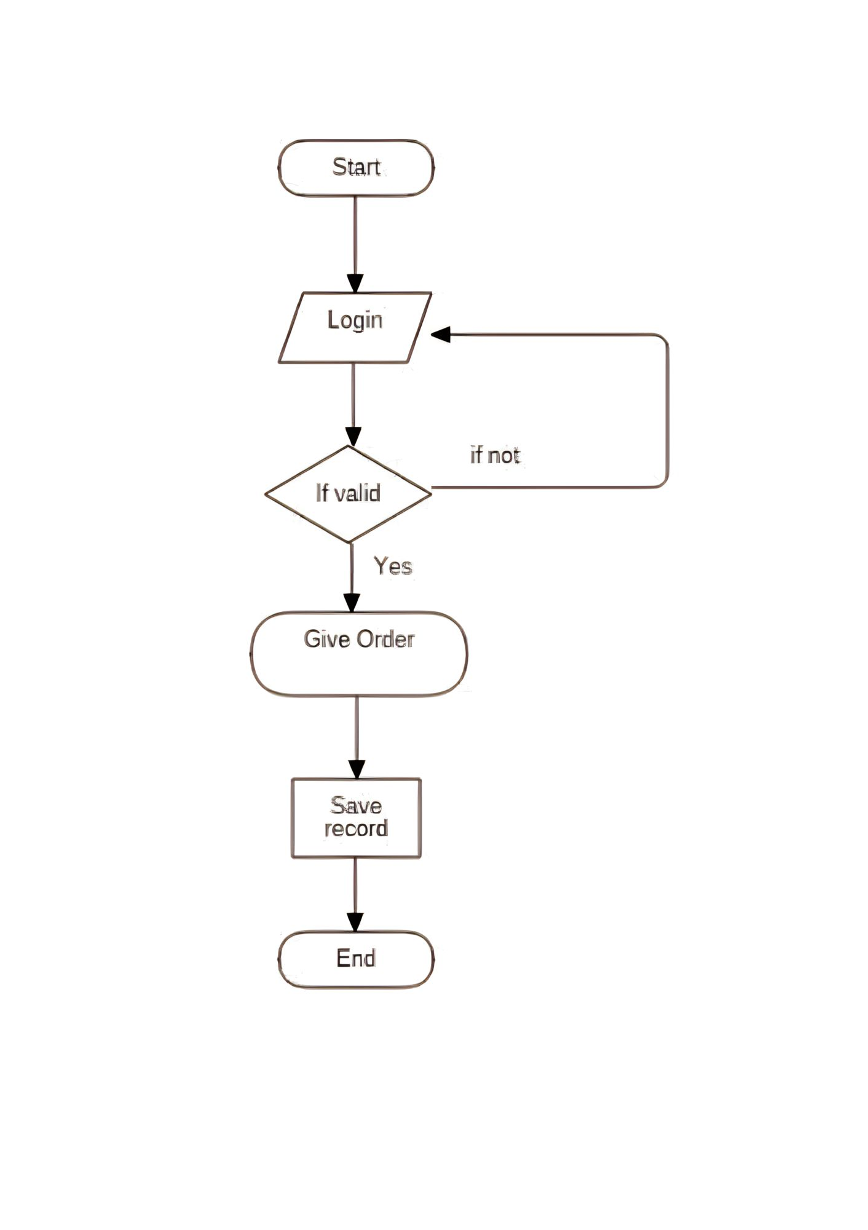

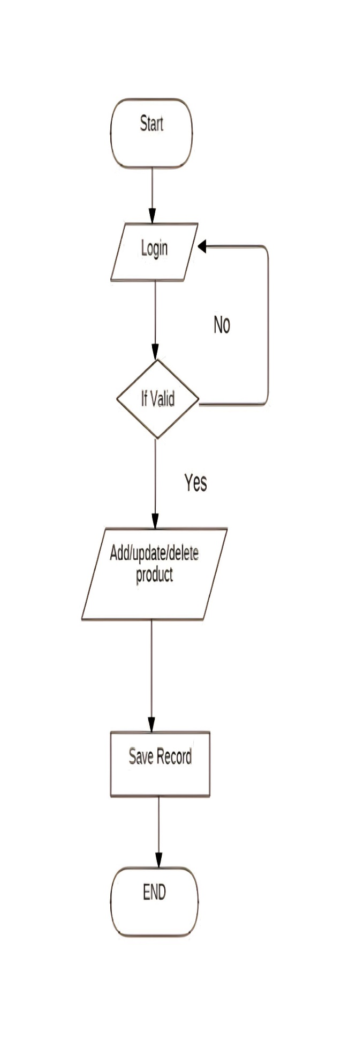

* 1. **Time Line Chart**

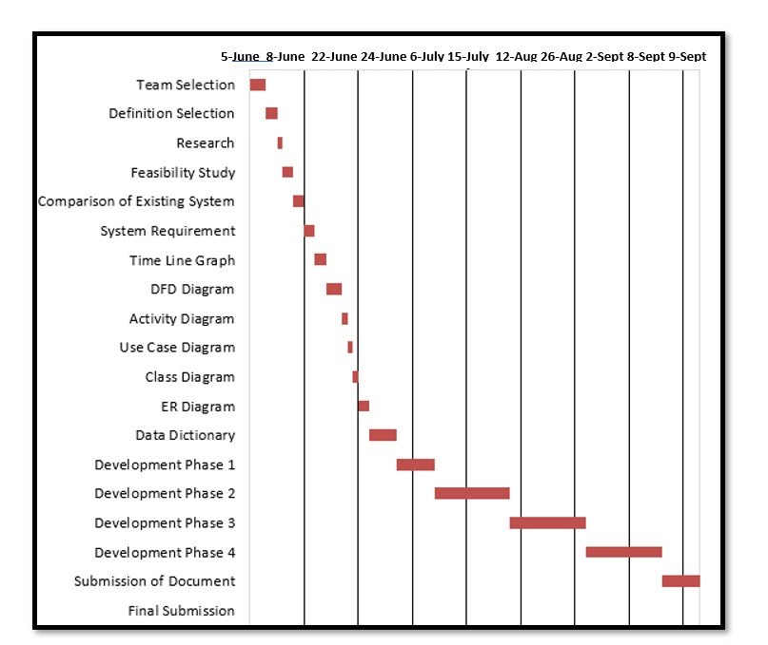

Figure 3.8 Time Line Chart

1. **Technology Description**
   1. **Features and Limitations of New System**

|  |  |
| --- | --- |
| **Existing System** | **New System** |
| Franchises are not available. | Franchises are available on site. |
| Online Payment are not available. | Online Payments are available now. |
| Cart System was not included. | Cart System is now available. |
| Single Item purchase was there. | Multiple Item can added to cart. |
| Additional Request for the user when ordering was not available. | Additional Request for the user when ordering was available now. |
| Café opening & closing hours was not available. | Café opening & closing hours is available. |
| Pre order for customer was not available. | Pre order is available now. |

1. **Data Flow Diagram**
   1. **Context Level DFD’s**

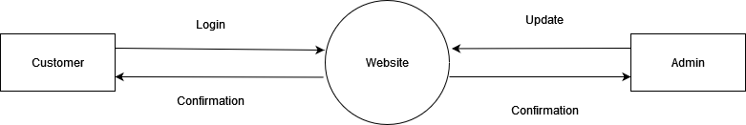

Figure 5.1. Context Level DFD: 0 Level

* 1. **Level 1 DFD’s:**

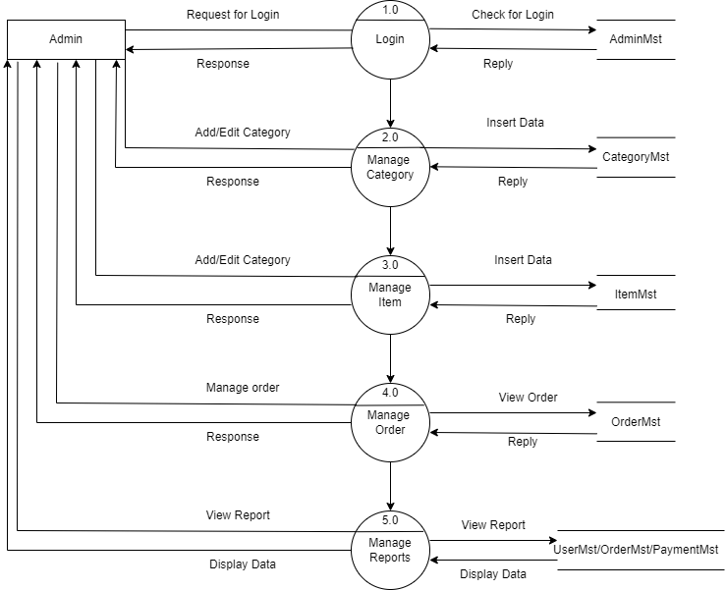

Figure 5.2. Level 1 DFD’s: 1 Level

* 1. **Level 2 DFD’s:**

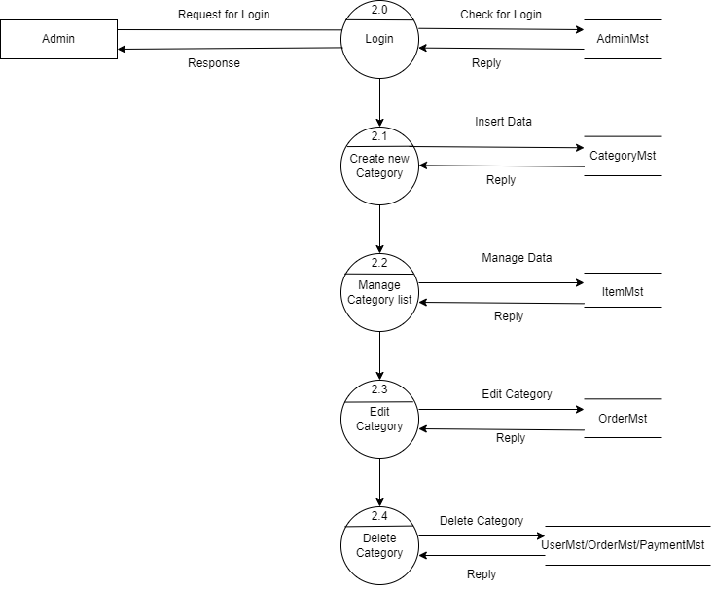

Figure 5.3 Level 2 DFD’s: 2 Level

* 1. **Level 3 DFD’s:**

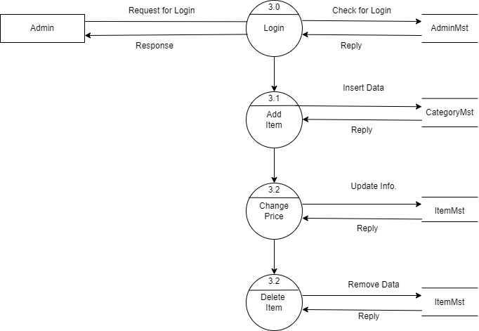

Figure 5.4 Level 3 DFD’s: 3nd Level

* 1. **Level 4 DFD’s:**

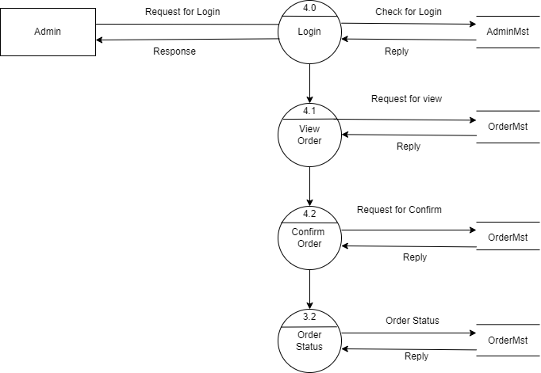

Figure 5.5 Level 4 DFD’s: 4th Level

* 1. **Level 5 DFD’s:**

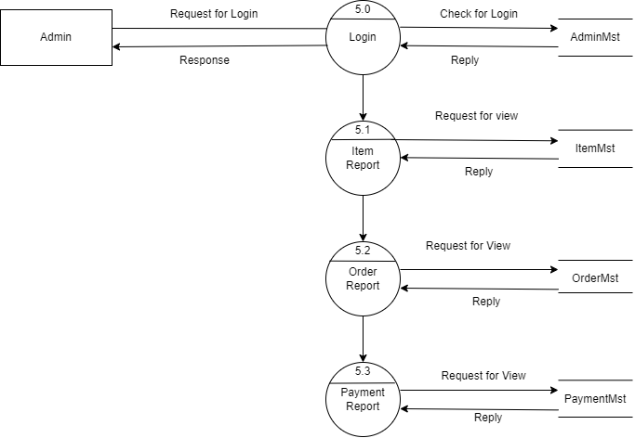

Figure 5.6 Level 5 DFD’s: 5th Level

1. **Use Case Diagram**

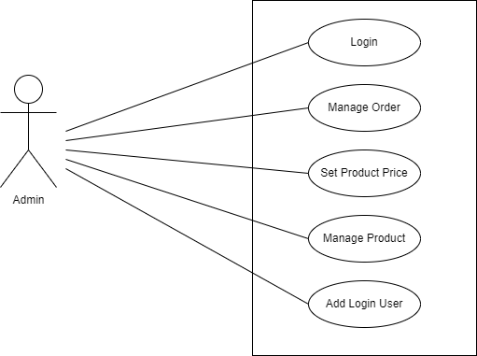

Use Case Diagram for Admin

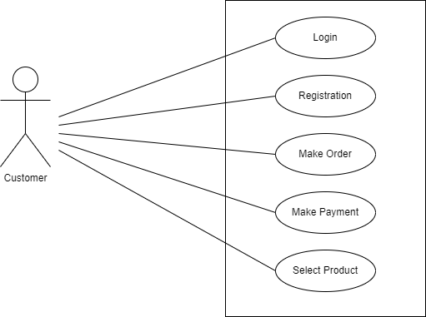



Figure 6. Use Case Diagram for Customer



1. **Class Diagram**

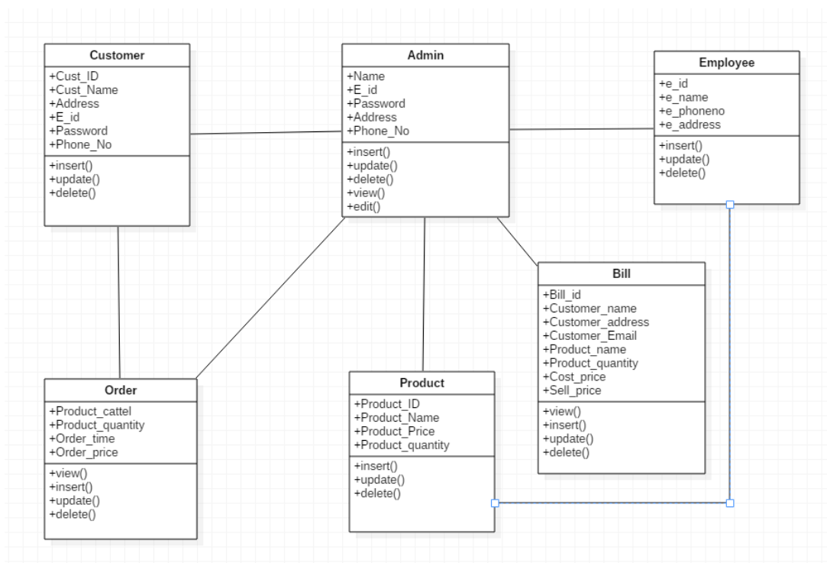

Figure 7. Class Diagram

1. **Activity Diagram**

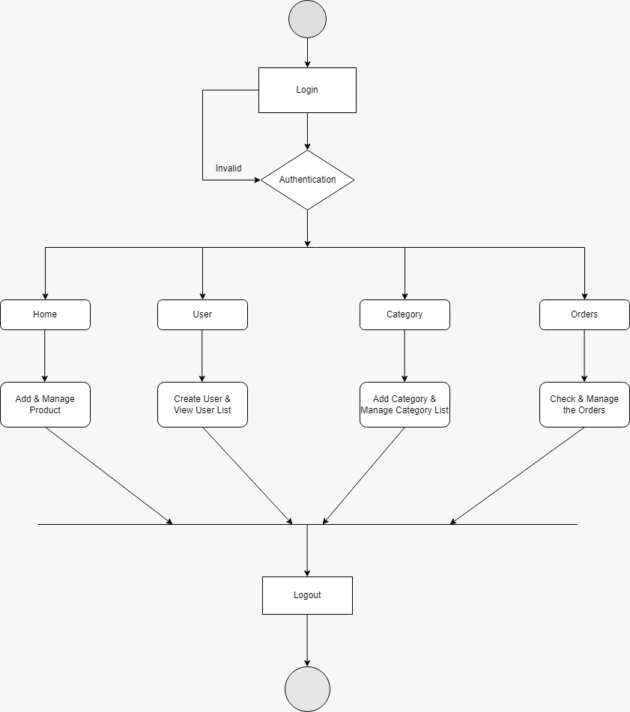

Figure 8. Activity Diagram

**8.1 Description of Activity Diagram**

An activity diagram provides a view of the behavior of a system by describing the sequence of actions in a process. Activity diagrams are similar to flowcharts because they show the flow between the actions in an activity; however, activity diagrams can also show parallel or concurrent flows and alternate flows. In activity diagrams, you use activity nodes and activity edges to model the flow of control and data between actions.

1. **E-R Diagram**

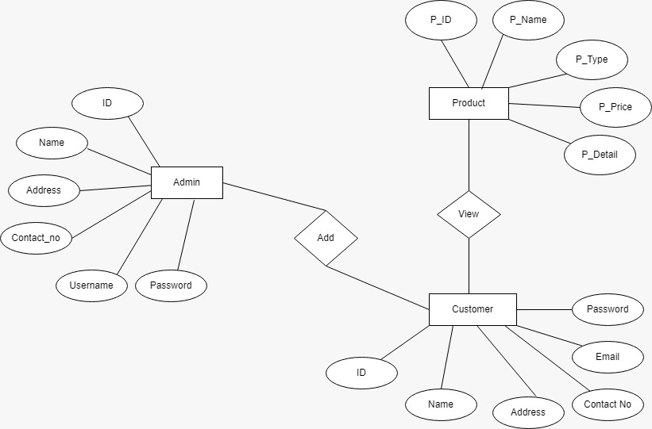

Figure 9. E-R Diagram

* 1. **Description of E-R Diagram:**

**ER Diagram** stands for Entity Relationship Diagram, also known as ERD is a diagram that displays the relationship of entity sets stored in a database. In other words, ER diagrams help to explain the logical structure of databases. ER diagrams are created based on three basic concepts: entities, attributes and relationships.

1. **Data Dictionary**
2. **Login Table:**

**Table Description:**

|  |  |  |  |  |  |  |
| --- | --- | --- | --- | --- | --- | --- |
| **Sr. No** | **Field Name** | **Datatype** | **Size** | **Description** | **Constraint** | **Example** |
| 1. | Username | Varchar | 50 | Username | Foreign Key | Vraj |
| 2. | Password | Varchar | 50 | password | Foreign Key | *** |
| 3. | Role | Varchar | 5 | User Role | Not Null | Admin, User |

1. **Customer Registration Table:**

**Table Description:**

|  |  |  |  |  |  |  |
| --- | --- | --- | --- | --- | --- | --- |
| **Sr. No** | **Field Name** | **Datatype** | **Size** | **Description** | **Constraint** | **Example** |
| 1. | Customer_id | Int | 11 | Customer ID Number | Primary Key | 001 |
| 2. | Customer_name | Varchar | 25 | Customer  Name | Not Null | Vraj |
| 3. | Email | Varchar | 50 | Customer Email | Not Null | abc@gmail.com |
| 4. | Mobile No | Big Int | 10 | Customer  Mobile No. | Not Null | 9754245262 |
| 5. | Gender | Varchar | 10 | Customer Gender | Not Null | Male, Female |
| 7. | User Name | Varchar | 20 | Customer User Name | Not Null | Vraj11 |
| 8. | Password | Varchar | 20 | Customer User Pass | Not Null | ***** |

1. **Product Table:**

**Table Description:**

|  |  |  |  |  |  |
| --- | --- | --- | --- | --- | --- |
| **Sr. No** | **Field Name** | **Datatype** | **Description** | **Constraint** | **Example** |
| 1. | p_id | Int | Id | Primary Key | 123569844 |
| 2. | p_price | Int | Price | Not Null | 179/- |
| 3. | p_image | Varchar | Image | Not Null | - |
| 4. | p_description | Varchar | Description | Not Null | Coffee |
| 5. | p_category_id | Int | Category id | Not Null | Caffe Latte |

* 1. **Description of Data Dictionary:**

A Data Dictionary is a collection of names, definitions, and attributes about data elements that are being used or captured in a database, information system, or part of a research project. It describes the meanings and purposes of data elements within the context of a project, and provides guidance on interpretation, accepted meanings and representation. A Data Dictionary also provides metadata about data elements.

1. **Form Design (Screenshots Phase 1 ,2,3,4 & validation’s screenshots)**

**11.1 Home Page User**

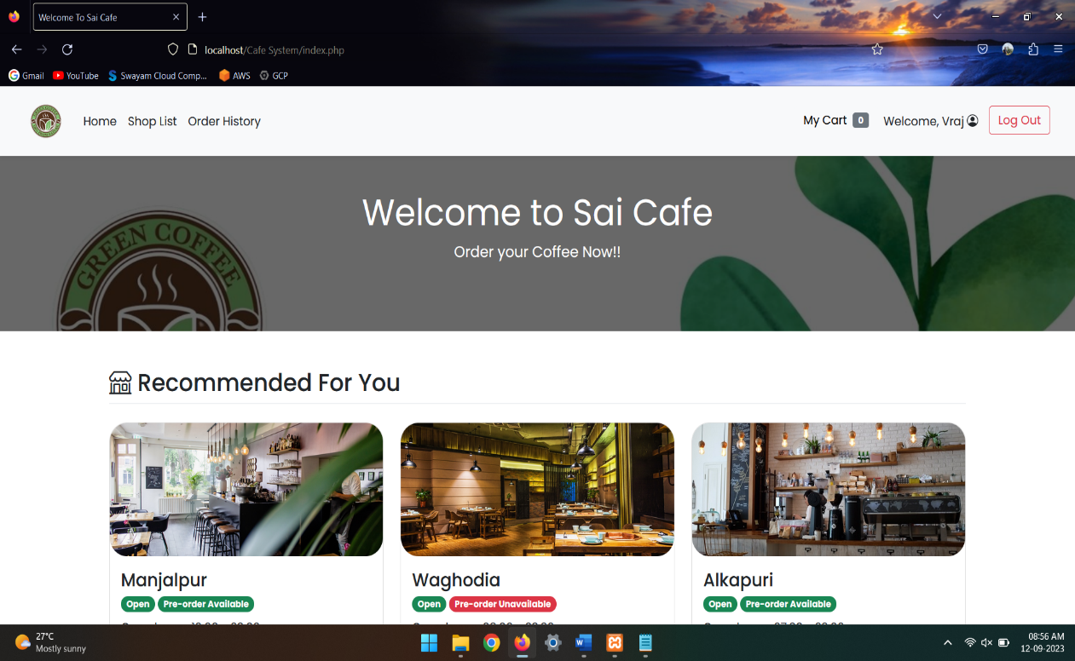

**Figure 11.1 Home Page User**

**11.2: Home Page Admin**

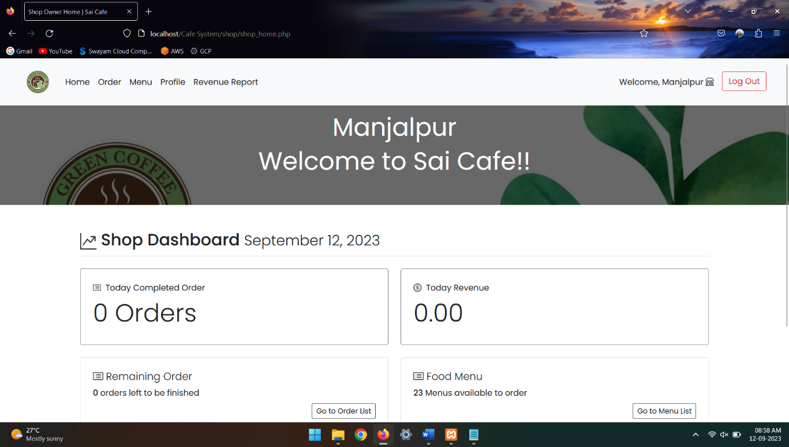

**Figure 11.2.1 Home Page Admin**

**11.3 Login Page User:**

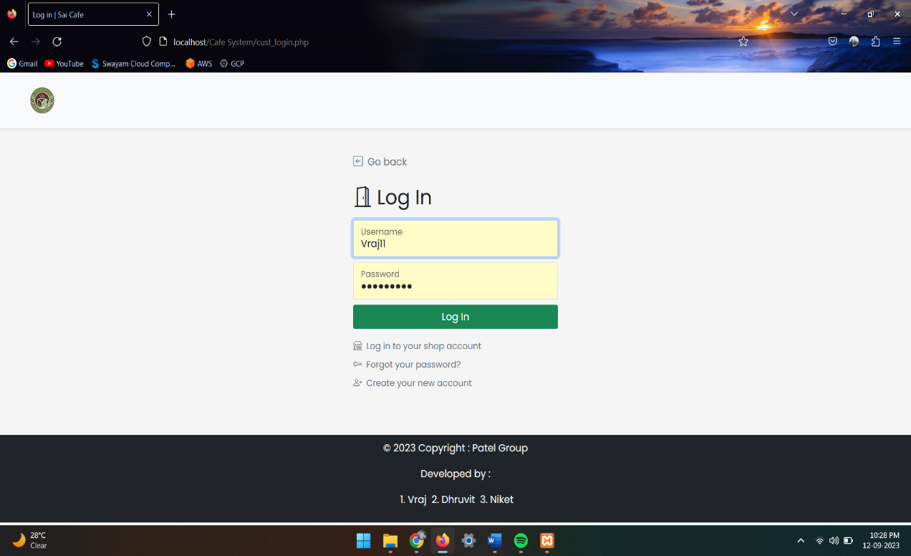

**Figure 11.3 Login Page User**

**11.4: Login Page Admin**

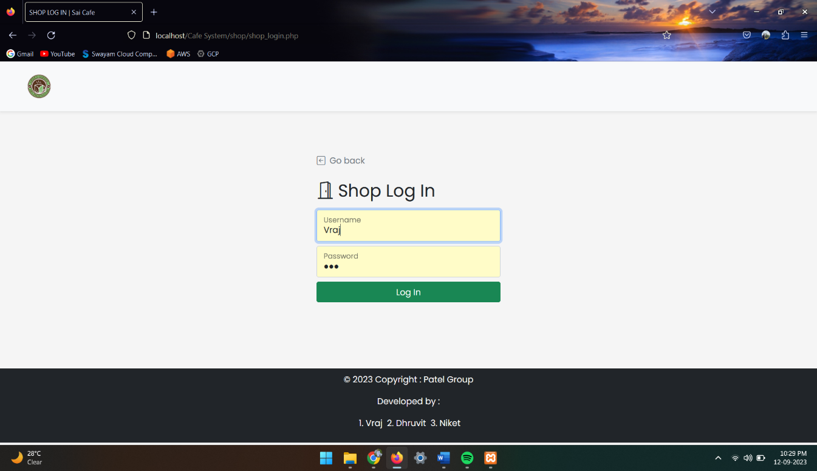

**Figure 11.4 Login Page Admin**

**11.5: User Cart**

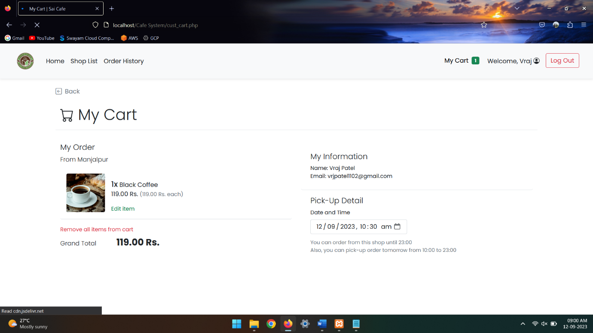

**Figure 11.5 User Cart**

**11.6: Shop Menu List**

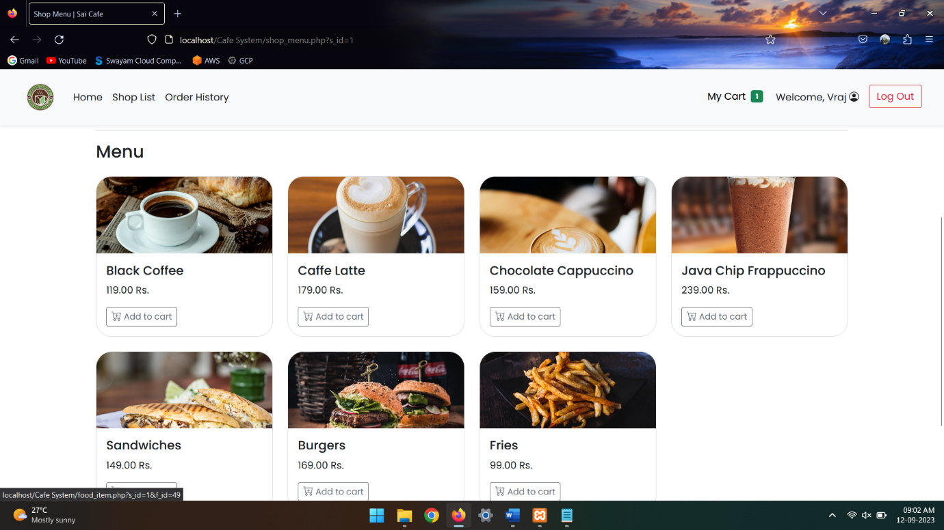

**Figure 11.6 Menu List**

**11.7: User Shop List**

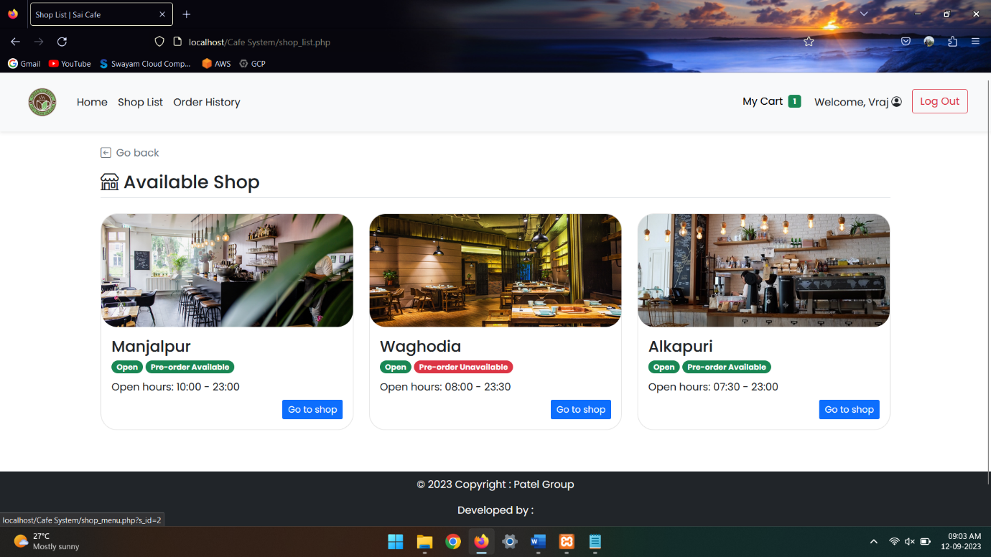

**Figure 11.7 User Shop List**

1. **What is Testing?**

Software testing is the act of examining the artifacts and the behaviour of the software under test by validation and verification. Software testing can also provide an objective, independent view of the software to allow the business to appreciate and understand the risks of software implementation.

**12.1. Importance and types of testing**

**Importance:**

Identifies defects early.

Improves product quality.

Increases customer trust and satisfaction.

Detects security vulnerabilities.

Helps with scalability.

Saves money.

**Types:**

Integration Testing.

Unit Testing.

Functional Testing.

Security Testing.

Performance Testing.

Regression Testing.

Stress Testing.

Acceptance Testing.

1. **Future Enhancement**

* Users will see offers on a particular shop.
* Online Delivery Services will be available soon.
* Add up item suggestions will update very soon.
* Live Customization will be added.
* More Branches will be added soon.
* Customer Feedback will be added.

**14. References & Bibliography**

Books: -

### [Headfirst PHP & MySQL (A Brain-friendly Guide)](https://geni.us/I99Tg)

**Author Name:** Lynn Beighley

**Publisher:** O′Reilly

### PHP and MYSQL for Dynamic Web Sites

**Author Name:** Larry Ullman

**Publisher:** Peach pit Press

Website: -

1. Code Master
2. PHP Point
3. Academia.edu

Resources: -

1. YouTube
2. Google